**Harnessing IT Innovations Across Industries**

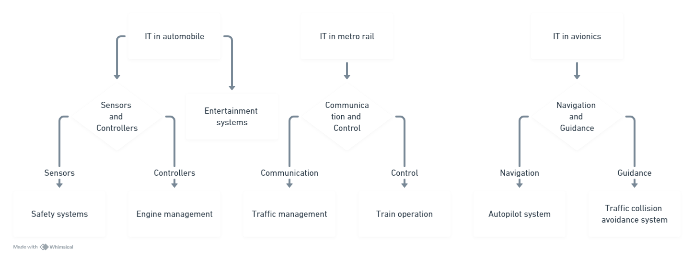

Ladies and gentlemen, today we embark on a journey through the realms of technology, exploring its transformative impact on various sectors of modern life. Our focus turns first to the bustling networks of metropolitan rail systems, where the convergence of information technology and transportation engineering has birthed a new era of efficiency and safety.

In the realm of metro rail, IT serves as the backbone of operations, orchestrating the intricate dance of trains, tracks, and passengers with precision and finesse. From automated scheduling algorithms that optimize travel times to real-time monitoring systems that ensure passenger safety, every aspect of metro rail operations is imbued with the power of information technology. Through the seamless integration of sensors, data analytics, and communication networks, IT empowers metro rail systems to deliver reliable, punctual, and convenient transportation services to millions of urban dwellers each day.

But our exploration of IT's influence does not end there. Let us now turn our gaze to the realm of automobiles, where the marriage of IT and automotive engineering has sparked a revolution in mobility. In today's interconnected world, cars have evolved from mere modes of transportation to sophisticated digital ecosystems on wheels. From advanced driver assistance systems that enhance safety to infotainment platforms that redefine the in-car experience, IT innovations are reshaping the automotive landscape in profound ways.

In the realm of avionics, IT takes flight to new heights, powering the cutting-edge technologies that propel aircraft through the skies. From flight management systems that optimize fuel efficiency to cockpit displays that provide pilots with real-time data insights, IT plays a pivotal role in ensuring the safety, reliability, and efficiency of modern air travel. With every takeoff and landing, IT in avionics exemplifies the relentless pursuit of innovation and excellence in the aerospace industry.

In conclusion, the influence of IT knows no bounds, permeating every aspect of our modern world, from the bustling corridors of metro rail systems to the open skies of avionics. As we continue to harness the power of technology to drive progress and innovation, let us remember the profound impact it has on shaping the way we live, work, and move through the world. Thank you.